.

Department Of Computer Engineering

**STES’S SINHGAD ACADEMY OF ENGINEERING**

**KONDHWA BK, PUNE 411048**

**2022-2023**

**“Health Related Medical Record System”**

**Submitted to the**

**Savitribai Phule Pune University**

**In partial fulfillment for the award of the Degree of**

**Bachelor of Engineering**

**in**

**Computer Engineering**

**By**

1. **Cedrick Andrade COBA006**
2. **Aishwarya Diwane COBA015**
3. **Pranav Chavan COBA109**
4. **Tanmay Dabhade COBA088**

Under the guidance of

**Prof. P. Hajare**



**CERTIFICATE**

This is to certify that the mini project report entitled **“Health Related Medical Record System”** being submitted by **Cedrick Andrade COBA006, Aishwarya Diwane COBA015, Pranav Chavan COBA109, Tanmay Dabhade COBA088** is a record of bonafide work carried out by him/her under the supervision and guidance of **Prof. P. Hajare** in partial fulfillment of the requirement for **BE (Computer Engineering) – 2019 course** of Savitribai Phule Pune University, Pune in the academic year 2022-2023.

Date:

Place: Pune

Subject Coordinator Head of the Department

Principal

This Mini Project report has been examined by us as per the Savitribai Phule Pune University, Pune requirements at **SINHGAD ACADEMY OF ENGINEERING** Pune – 411048 on . . . . . . . . . .

Internal Examiner External Examiner

**ACKNOWLEDGEMENT**

First and foremost, praises and thanks to the God, the Almighty, for showers of blessings throughout my project work to complete the research successfully.

I would like to express my deep and sincere gratitude to my subject teacher Prof. P. Hajare for giving us the opportunity to do this project and provide invaluable guidance throughout this project. Her dynamism, vision, sincerity and motivation have deeply inspired us. He has taught us the methodology to carry out the research and to present the project works as clearly as possible. It was a great privilege and honor to work and study under her guidance. We are extremely grateful for what she has offered us. We would also like to thank him for his friendship, empathy, and great sense of humor.

We are extremely grateful to all group members Cedrick Andrade, Aishwarya Diwane, Pranav Chavan, Tanmay Dabhade for the dedication and consistency towards this mini project. And also thankful for all the resources which are provided by each group member and which played a very crucial role in the accomplishment of this project.

(Students Name & Signature)

**CONTENTS**

|  |  |  |
| --- | --- | --- |
| **Sr. No** | **TITLE** | **Page no** |
| **1.** | Abstract | **5** |
| **2.** | Introduction | **6** |
| **3.** | Problem Statement | **6** |
| **4.** | Motivation | **6** |
| **5.** | Objectives | **7** |
| **6.** | Theory | **7** |
| **7.** | Conclusion | **12** |
| **8.** | References | **13** |

**Abstract**

In today’s digital world, information is exchanged between systems and it is expected that each interaction / transaction between the systems is secure and reliable. Blockchain technology can be applied to protect the security of healthcare data. It is important to have access control mechanism that allows only authorized persons to share the medical data. In this work, we introduce a blockchain based system for securely sharing health records. The system includes a smart contract based data protection and accessibility mechanism.

**Introduction**

Blockchain is a new technology used for sharing medical records without the need of third party introversion. Blockchain was used in the distributed ledger framework and bitcoin was developed in October, 2008.

The initial use of blockchain is the digital currency such as Bitcoin referred to as Blockchain 1.0.

Blockchain 2.0 was concerned with smart properties / assets which are developed using blockchain-based platform and smart contracts which are software programs that encode instructions to control the smart properties and its processing mechanism. Some of the applications of Blockchain 2.0 are Ethereum, Ethereum Classic, NEO and QTUM.

Blockchain 3.0 deals with non-financial applications.

Blockchain is considered to have potential applications in various businesses such as identity management, logistics, insurance, healthcare and etc.

In this work, we propose a system to maintain and

process health records of patients safely and securely. The

system is based on the blockchain technology for protecting

the integrity and security of health data. The healthcare

management system consists of structures to hold the patient data and functions to add and retrieve patient data.

**Problem Statement**

Develop a Blockchain based application for health related medical records.

**Motivation**

Blockchain being the new and interesting emerging field has paved the path for many developers to create secure immutable applications in trustless environment. Hence as part of our curriculum we decided to create a Medical Health Record System that could be free from manipulation and facilitate easy data storage and recovery.

**Objectives**

1. To understand and explore the working of Blockchain technology and its applications.
2. To create a blockchain application to store health related medical records.

**Theory**

Blockchain works by creating decentralized distributed ledgers that are circulated over all devices participating in the system. It allows to share records based on peer-to-peer replication, and processing by all nodes in the network namely, transacting nodes and validating nodes. When records are placed in the ledger, all nodes in the network go through encryption procedures and are processed by all miners. The blockchain provides highly reliable storage

of data and makes use of consensus strategy, digital signatures, and hash of each block.

Blockchain provides many features such as integrity, traceability, safety, and security for protection of data. Blockchain is applied in both private and government sectors. Applications of Blockchain technology in healthcare data security are EHRs, Drug and Medical Supply Chains and Medicine Development.

**Emergency Healthcare Record(EHR)**

Medical data is highly critical; safe and secure accessing and usage of these data is extremely important. A few authentication schemes are introduced in to enable efficient data accessibility, manageability and other key security issues are also presented. Various usage of Blockchain in healthcare is presented in. Remote access of patient’s information and protection of privacy of healthcare data are some of the important applications of Blockchain Technology.

**Advantages of EHRs:-**

1. Real-time, factual and complete details about the patient are fetched.
2. Data can be accessed from any place.
3. Patients have more autonomy over their personal data.
4. Data privacy and protection will be improved.
5. Coordination between patients and various healthcare departments is improved.
6. Money and time are saved.

**Disadvantages of EHRs:-**

1. It cannot accommodate multi-institutional complexities or maintain lifetime medical records.
2. Data is dispersed among various institution.
3. Data Manipulation
4. No easy accessibility of information in the case of multi-institutions.

**Use Case of Blockchain in EHRs:-**

**MedRec** proposed a decentralized method for utilizing blockchain technology to deal with the EHR/EMR and presented a use case of blockchain in healthcare. Healthcare records and queries require robust access control mechanism to reduce the threat of data hacking. Also, use of cryptographic algorithms in the frameworks may make encryption of medical records more complex.

**Code:-**

//LP3 Group C Mini Project Health Care Records

//Cedrick Andrade COBA006

//Aishwarya Diwane COBA000

//Pranav Chavan COBA000

//Tanmay Dhabde COBA000

//SPDX-License-Identifier: MIT

pragma solidity ^0.6;

contract Health_Record

{

    struct Patient

    {

        int patient_id;

        string name;

        string height;

        string weight;

        string disease;

        string symptom1;

        string symptom2;

    }

    Patient[] Patients;

    function addPatient(int patient_id, string memory name, string memory height, string memory weight, string memory disease, string memory symptom1, string memory symptom2) public

    {

        Patient memory patient = Patient(patient_id,name,height,weight,disease,symptom1,symptom2);

        Patients.push(patient);

}

    function getPatient(int patient_id) public view returns(string memory, string memory, string memory, string memory, string memory, string memory)

    {

        for (uint i=0; i<Patients.length; i++)

        {

            Patient memory patient = Patients[i];

            if(patient.patient_id==patient_id)

            {

                return(patient.name,patient.height,patient.weight,patient.disease,patient.symptom1,patient.symptom2);

            }

        }

        return("Name not Found", "Height not Found", "Weight not Found", "Disease not Found", "Symptom1 not Found", "Symptom2 not Found");

    }

}

**Output:-**

**Deploying the Contract:-**

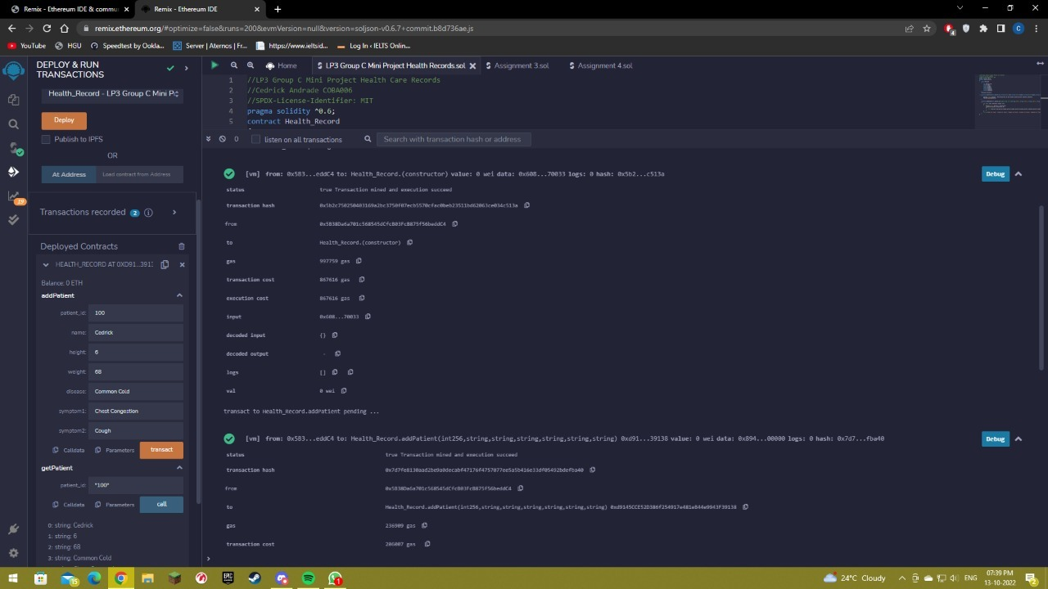

**Adding Patient Data:-**

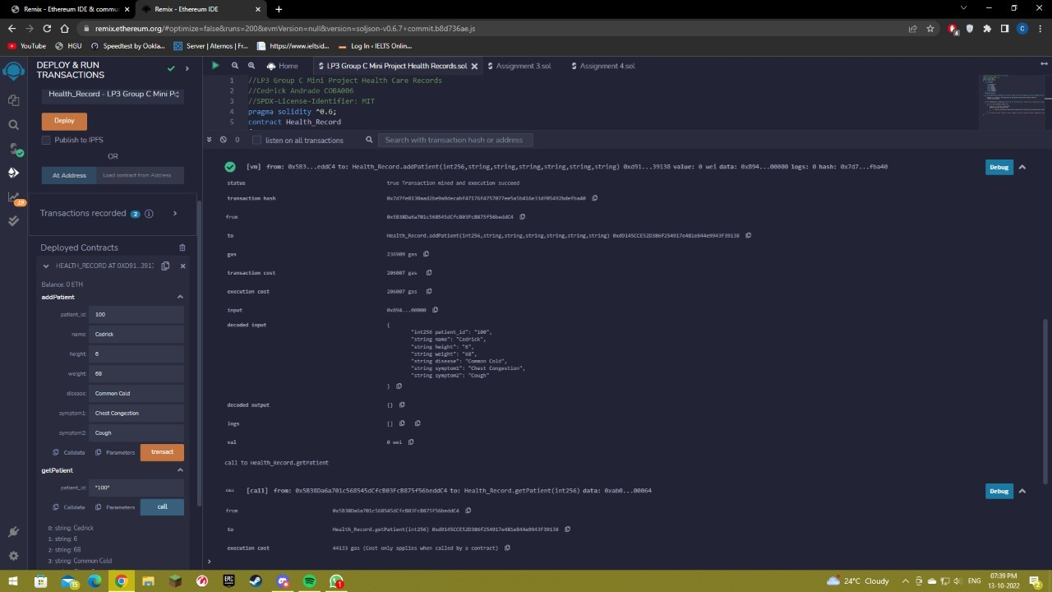

**Retrieving Patient Data:-**

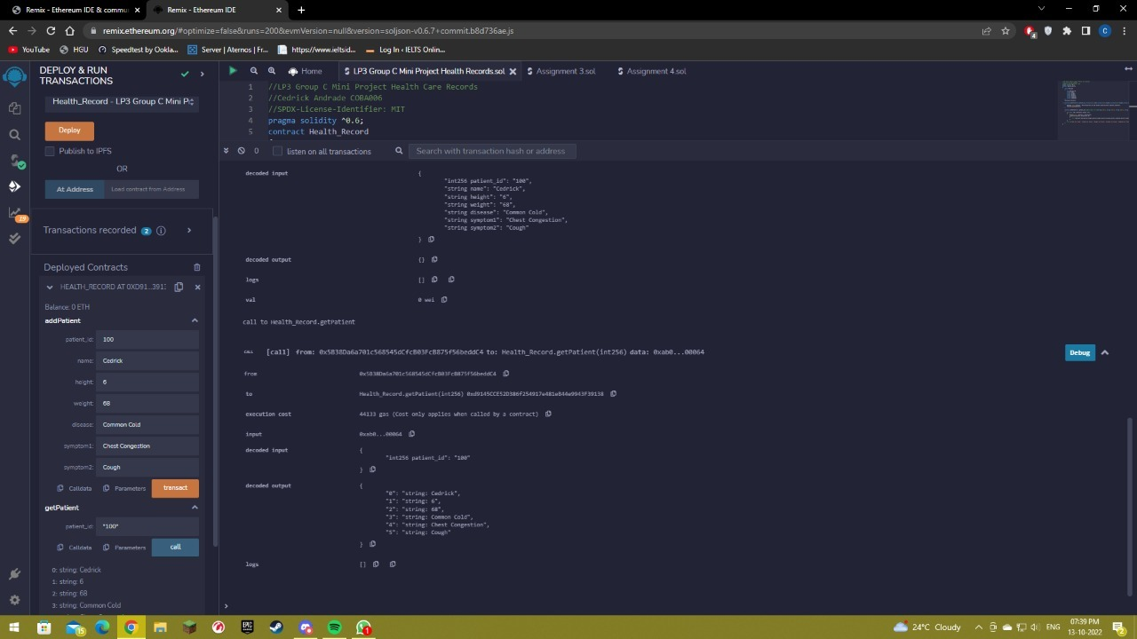

**Conclusion**

Thus, we have implemented a Health Related Medical Record System using Blockchain.

**References**

* Techknowledge Publications Blockchain Technology
* Healthcare Data Protection Based on Blockchain using Solidity by C. Devi Parameswari Department of Computer Applications, Kalasalingam Academy of Research and Education Krishnankoil, India and Venkatesulu Mandadi Department of Information Technology, Kalasalingam Academy of Research and Education Krishnankoil, India.
* https://remix-ide.readthedocs.io/en/latest/